theSource CIF Commercial
Overview
CIF
Client Info Section
Client Specific Process Section
Need to Know
Open Enrollment
Eligibility
Fulfillment
Retail Logic
Plan Design Highlights
Specialty Plan Design Highlights
Overrides
Prior Authorizations
Appeal Process
Exception Process
Paper Claims
Client Programs & Offerings
Related Content

Overview
This job aid provides information about how the CIF will display in theSource. The sections are organized to make it easy to find and identify client specific processes.

Top of the Document

CIF
When viewing a CIF, the initial screen will auto-display all of the CIF sections in the Collapsed view.

To view the details of:
- Each individual section: Select the down arrows to the right.
- All sections at once: Select the “Expand All” button. If you select the “Collapse All” button, it will return you to the collapsed view.

Example of this initial screen:

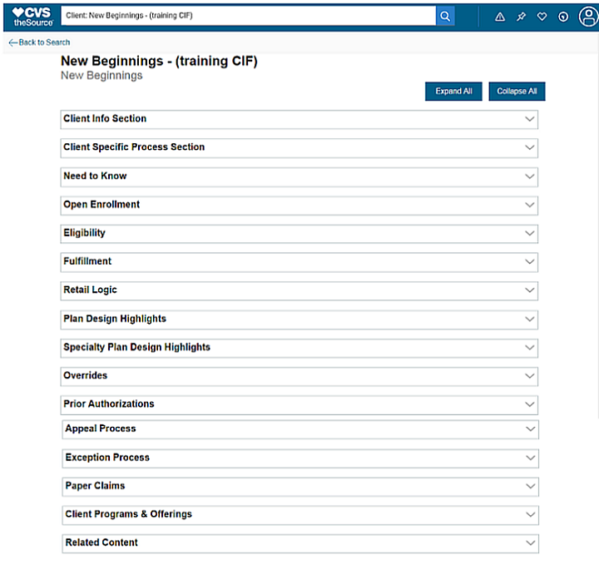

Not all sections/categories apply to all clients. Sections or categories that are not populated, will not display. This means that theSource will only show content relevant to the client.

Reminder: Use CTRL+F to find key words to help locate a specific topic.

Top of the Document

Client Info Section
The Client Info Section provides an overview of some key information about the client.

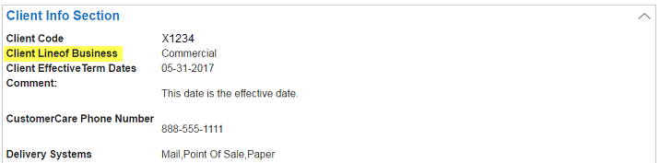

Top of the Document

Client Specific Process Section
The Client Specific Process section details the key plan options that the client has in place.

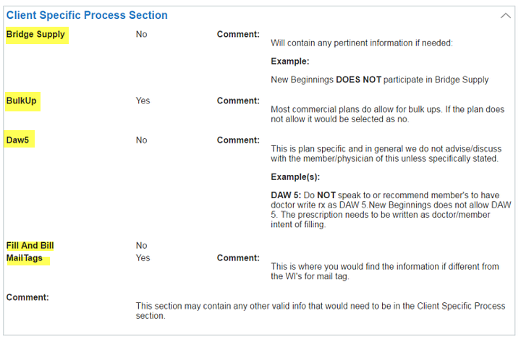

Top of the Document

Need to Know
The Need to Know section is where you will find items that do not have a section of their own or is an immediate “need to know” item.

Top of the Document

Open Enrollment
The Open Enrollment section details information pertinent to clients for whom we support Open Enrollment.

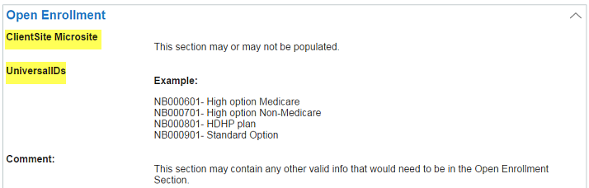

Top of the Document

Eligibility
The Eligibility section contains information about how the client’s eligibility is set up.

Top of the Document

Fulfillment
The Fulfillment section contains information about who handles ID Card mailings and if the client participates in the ExtraCare Health Card program.

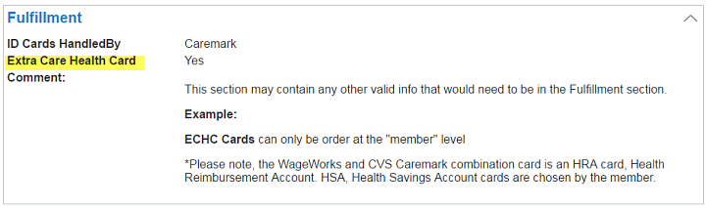

Top of the Document

Retail Logic
The Retail Logic section outlines the components necessary to process a claim.

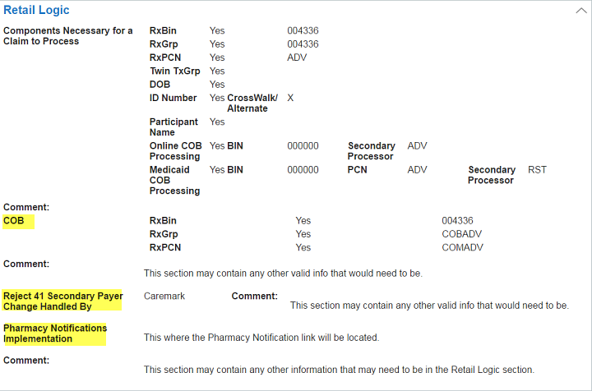

Top of the Document

Plan Design Highlights
The Plan Design section outlines key elements of the client’s plan design.

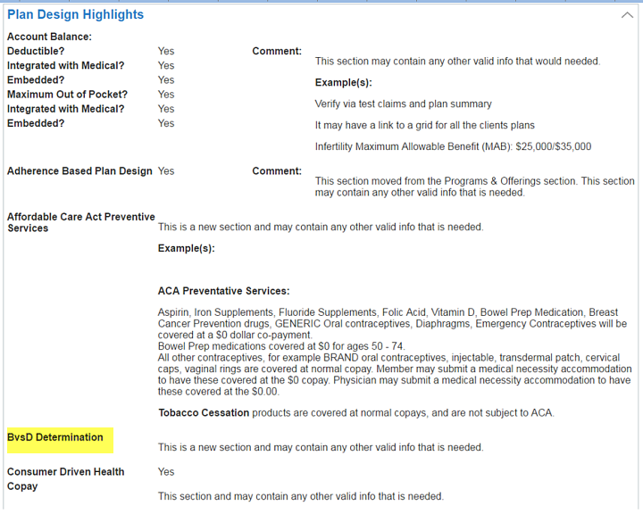
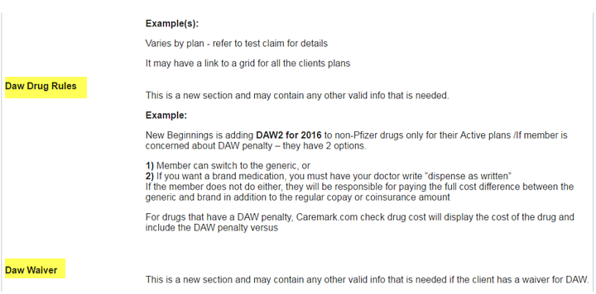
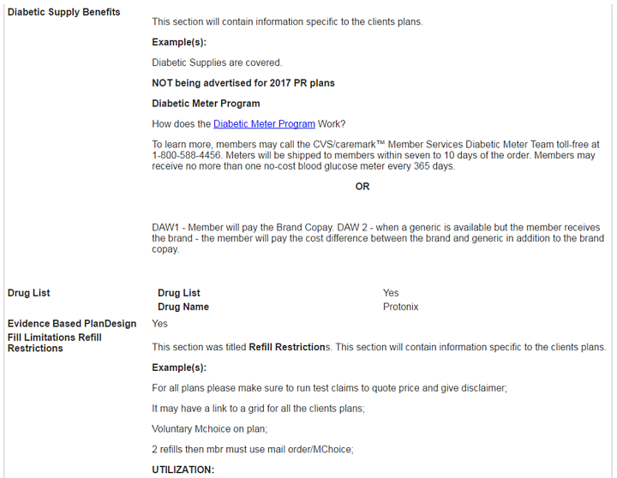
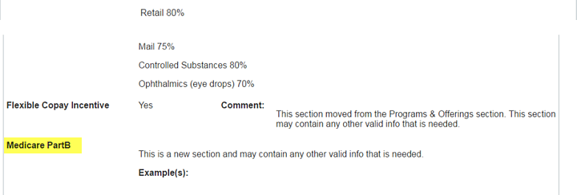
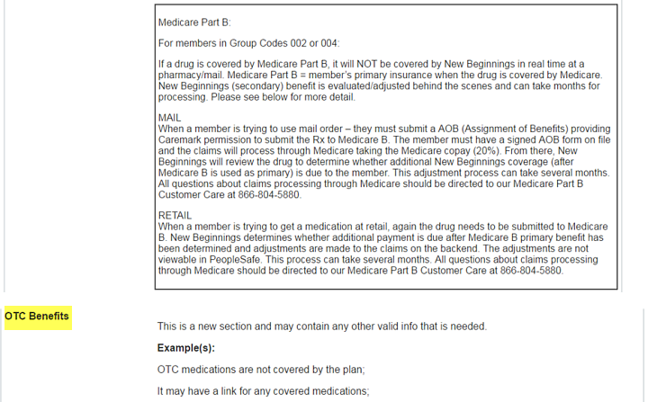
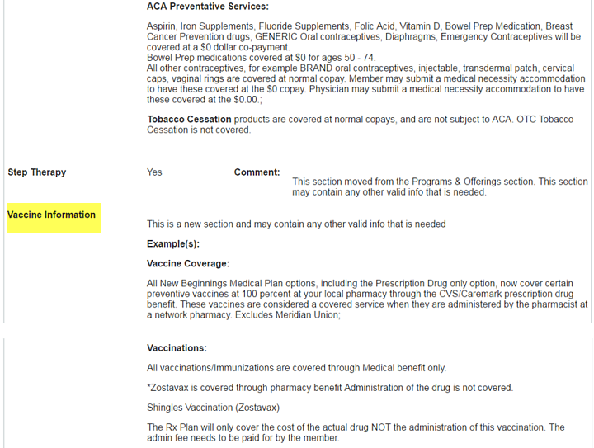
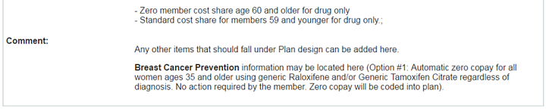

Top of the Document

Specialty Plan Design Highlights
The Specialty Plan Design Highlights section provides information on key aspects of the client’s specialty offerings.

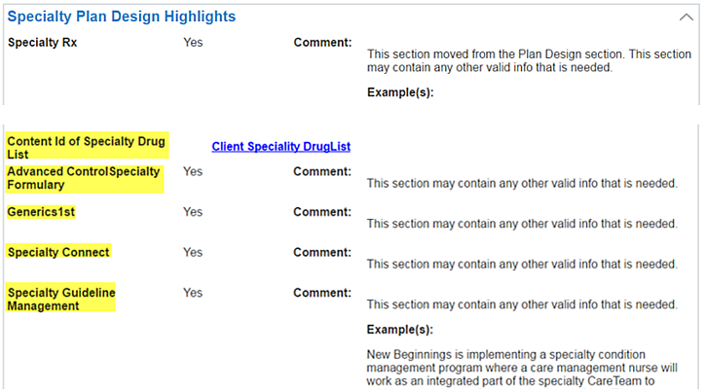

Top of the Document

Overrides
The Overrides section contains the information on which overrides are allowed by the plan.

A Comment Field is at the top of the section, which can include instructions applicable to all overrides. Be sure to review this information prior to entering an override. Additionally, all PBOs are listed in alphabetical order.

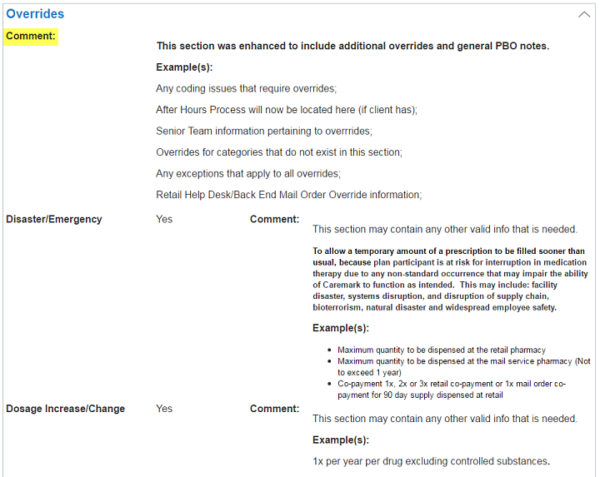

Top of the Document

Prior Authorizations
The Prior Authorization section provides information about who handles Prior Authorizations.

Top of the Document

Appeal Process
The Appeal Process section provides information about who the appeals processor is and the various levels of appeal available to members.

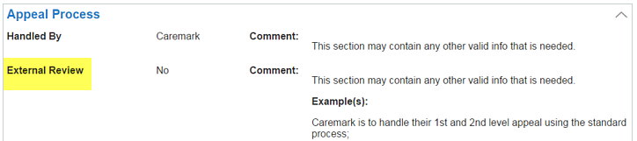

Top of the Document

Exception Process
The Exception Process section outlines the client specific exceptions offered outside of the standard PA/Appeals process.

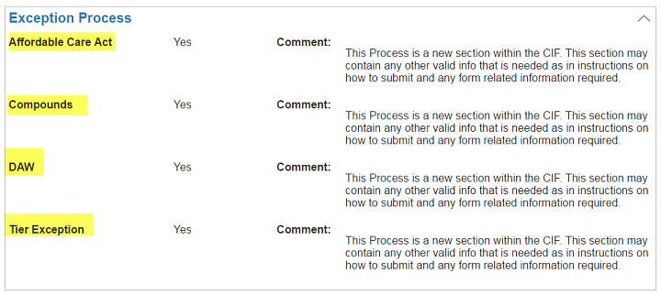

Top of the Document

Paper Claims
The Paper Claims section provides a comprehensive list of the various types of paper claims allowed by the plan.

Top of the Document

Client Programs & Offerings
This section outlines the Client Programs and Offerings available to members.

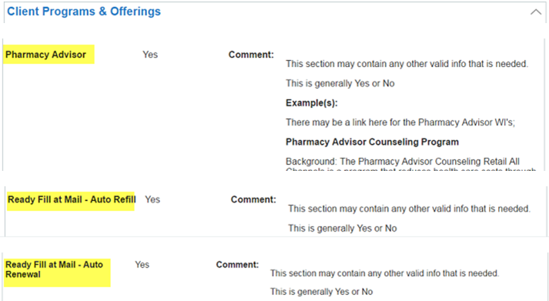

Top of the Document

Related Content
This section provides links to related content (samples) for the client, such as Job Aids, Drug List, Matrices, etc.



Top of the Document

Not To Be Reproduced Or Disclosed to Others Without Prior Written Approval
ELECTRONIC DATA = OFFICIAL VERSION / PAPER COPY = INFORMATIONAL ONLY

